ELEKTRONIK 3
DELTA-SIGMA ADC AND DAC

- GOAL / PROBLEM
In this experiment, the structure and properties of a Delta-Sigma ADC and DAC will be examined. To prepare the lecture notes are gone through on the subject.
- EXPERIMENTAL PREPARATION
In preparing a 74HC74 flip-flop is to use so that the chip works as a D-FF. The D flip-flop operation is achieved by "RD" and "SD" are constantly drawn to "high". All input pins need necessarily a defined state.

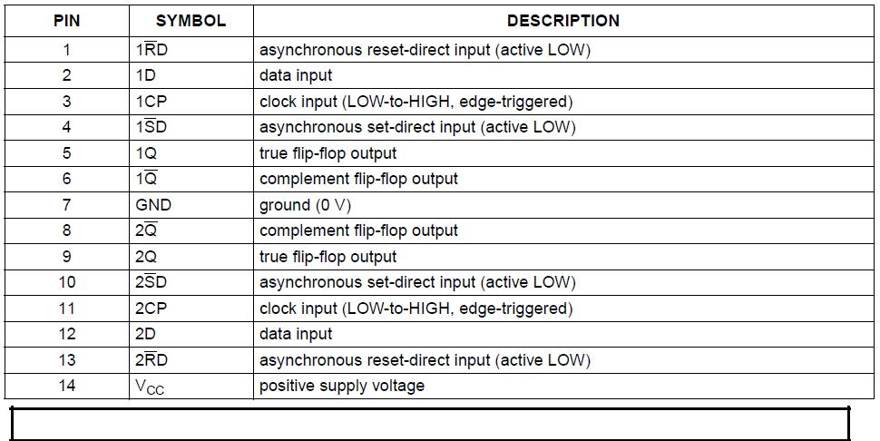

- EXPERIMENTAL PROCEDURE
  - DELTA-SIGMA DAC - INVESTIGATION OF SIGNALS
The circuit has been built in this part as follows:
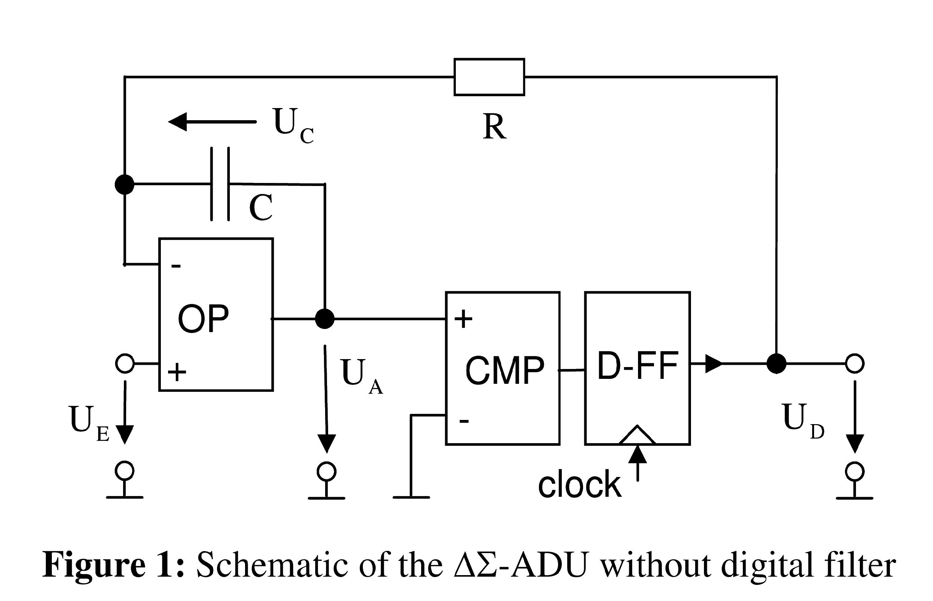
- It shall be the ratio of H and L at UD for UE = 2.5V observed. This is triggered to UA. The following image was taken with the following components:
capacitor C =
resistance R =
sampling fA = 50kHz
input voltage UE = 2.5V
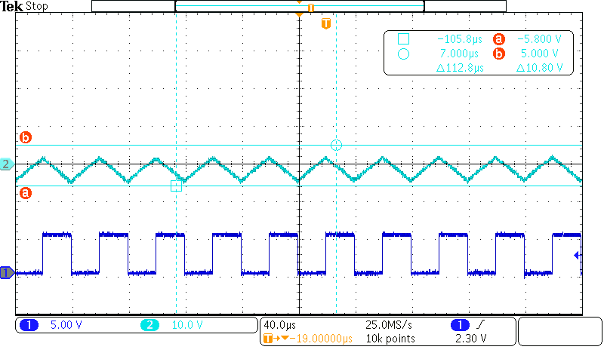
Figure 2: Measured at UE =

The oscilloscope shows the clock (purple), the voltage UA (turquoise) and the voltage UD (blue). In addition, it can be seen that the high and low levels are evenly distributed, since we have selected as the input voltage. If you change the input voltage UE, so the ratio of high and low level would change. With an input voltage of UE = 0V are only low-level and at an input voltage of 5V UE = only high-level can be seen.
2.1) Examination of the input and output signals

In the measurements it can be seen that changing the ratio of high and low levels of the output voltage for a change in the input voltage. At the ratio of the level of the output voltage can calculate the input voltage.
c. Observation
Now we at an input voltage of 5V and a UE = resistance of R = X, X kOhms, the capacitor capacitance C changes.
5V fixed
1.5 nF 4.8V
500pF → limit
3,3nF → time constant is longer
By the change in the capacitance, the time constant Tau changed. The smaller Tau is, the faster recharges the capacitor. It follows that the running time is reduced.
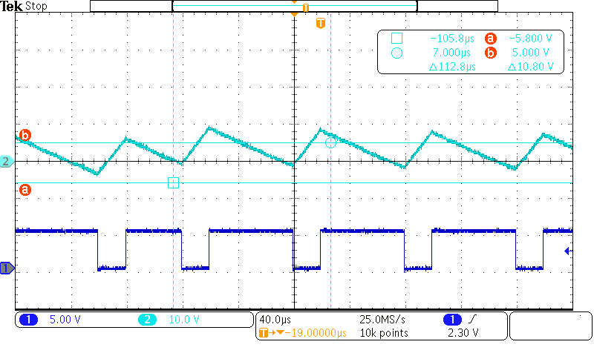
d.Observation
Now we changed at an input voltage of 5V and a capacitor UE = capacitance of C = 1,492nF the resistance R.
5V fixed
7.1 kOhm
3,7kOhm
Here come the same phenomena as in c.) By changing the resistance, the time constant tau is changed. If the resistance is too small, then it is possible that the capacitor is charging too fast and thus goes to the limit. This can cause the circuit no longer works properly.
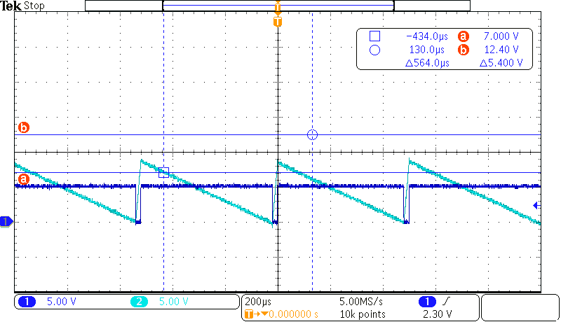

e.Observation
In this part, the approximate frequency fx is to be determined, at the beginning the circuit no longer provides proper output voltage values.
By lowering the sampling frequency of the peak voltage UA is "cut off". Thus, the system begins to incorrect values for the output voltage supply. At the frequency f <fx the capacitor is fully charged.
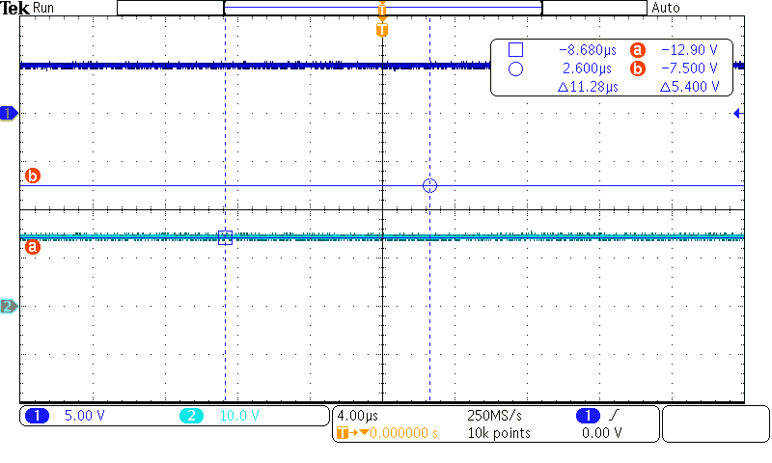
f.Observation
Now we set for fA = f / 2. The value of R and / or C is set so that the system is delivering the correct values.
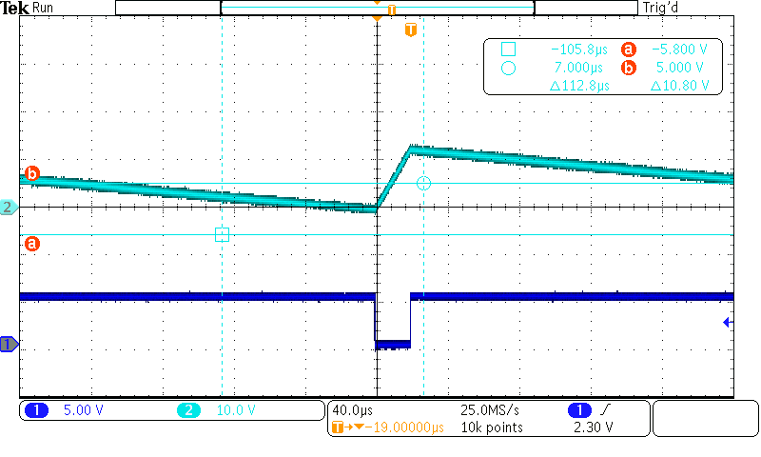

2.2) Measurements
The DC component of the output voltage UD is measured in an analog way (usually UD is first processed in a digital filter). This analog method is a way to measure the quality of the chain of a DAC and a ADC.
Lab tasks: Keep C=1,5 nF, R=5 kOhms and fA=50 kHz. Measure the average of UD for UE = k0,25 V (k=0,1,2….) from 0 V to 5 V and make a table with UD vs. UE.

